Worksheet - 5

**NAME: Hari Krishnan**

**SEC-DWWC 43**

**UID: 20BCS2000**

**Date- 09 /01/2023**

**Que-1:** [**Implement Queue using Stacks**](https://leetcode.com/problems/implement-queue-using-stacks/description/) **Code:**

class MyQueue { stack<int> s;

public:

MyQueue() {

}

void push(int x) { if(s.empty())

s.push(x); else{

stack<int>temp; while(!s.empty()){

temp.push(s.top()); s.pop();

}

s.push(x); while(!temp.empty()){

s.push(temp.top()); temp.pop();

}

}

}

int pop() {

int ans = s.top(); s.pop();

return ans;

}

int peek() {

return s.top();

}

bool empty() {

return s.empty();

}

};

**Output:**

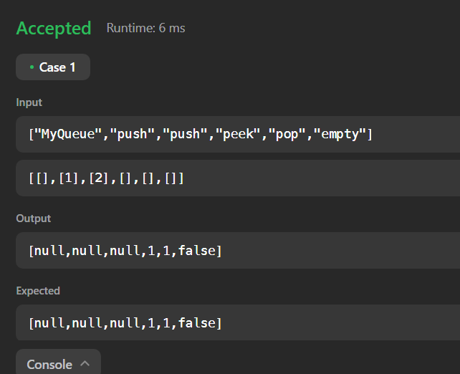

**Que-2:** [**Min Stack**](https://leetcode.com/problems/min-stack/description/)

**Code:**

class MinStack { public:

ListNode *head; ListNode *min; MinStack() {

head=nullptr;

}

void push(int val) { if(!head){

head= new ListNode(val); min=new ListNode(val);

}

else{

ListNode *temp=new ListNode(val); temp->next=head;

head=temp; if(val<=min->val){



ListNode *tempmin=new ListNode(val);

tempmin->next=min; min=tempmin;

}

}

}

void pop() {

if(head->val==min->val) min=min->next;

head=head->next;

}

int top() {

return head->val;

}

int getMin() { return min->val;

}

};

**Output:**

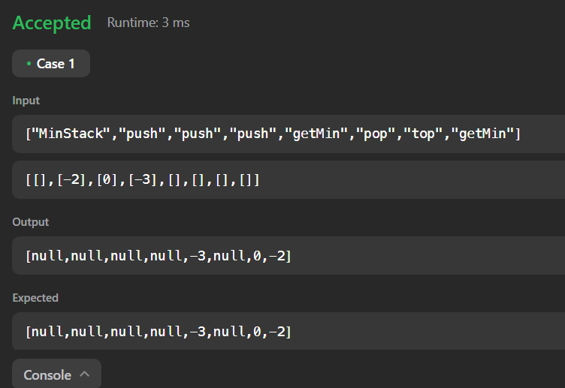

**Que-3:** [**First Unique Character in a String**](https://leetcode.com/problems/first-unique-character-in-a-string/description/)

**Code:**

class Solution { public:

int firstUniqChar(string s) { unordered_map<char,int> map; for(int i=0;i<s.size();i++){

map[s[i]]++;

}

for(int i=0;i<s.size();i++){ if(map[s[i]]==1){

return i;

}

}

return -1;

}

};

**Output:**

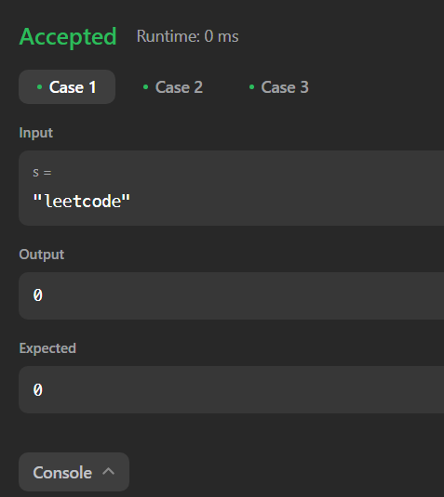

**Que-4:** [**Longest Valid Parentheses**](https://leetcode.com/problems/longest-valid-parentheses/description/) **Code:**

class Solution { public:

int longestValidParentheses(string s) { stack<int> st;

st.push(-1); int ans=0;

for(int i=0;i<s.size();i++){ if(s[i]=='('){

st.push(i);

}

else{

st.pop(); if(st.empty()){

st.push(i);

}

else{

if(ans<i - st.top())

ans = i - st.top();

}

}

}

return ans;

}

};

**Output:**

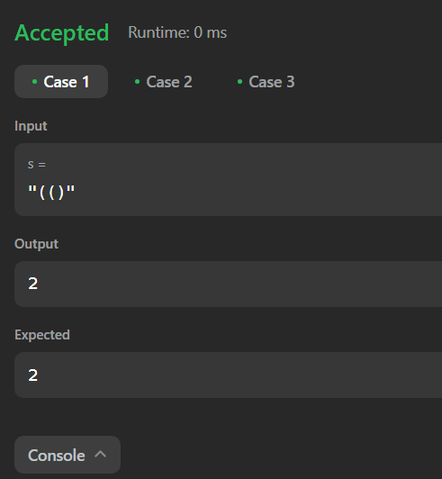

**Que-5:** [**Validate Stack Sequences**](https://leetcode.com/problems/validate-stack-sequences/description/)

**Code:**

class Solution { public:

bool validateStackSequences(vector<int>& pushed, vector<int>& popped) { stack<int> st;

int j = 0;

for(auto val : pushed){ st.push(val);

while(st.size() > 0 && st.top() == popped[j]){ st.pop();

j++;

}

}

return st.size() == 0;

}

};

**Output:**

